## CSCE 606 SOFTWARE ENGINEERING - Iteration 0

### Team & Roles:

* Aravind Badavath
* Chetan Nagavathi Chendrayudu
* Gokul Sai Doppalapudi
* Jeya Krishna Chandu Akula
* Shyam Prasad Nagulavancha(Scrum Master)
* Rajendra Thottempudi(Product Owner)

### Project Links:

* [Github Link](https://github.com/shyam-prasad-na/CSCE606_CodeJudge)
* [Pivotal Tracker](https://www.pivotaltracker.com/n/projects/2600881)

### Customer Meeting date/time/place:

Met with client Dr. Ritchey by emailing for a preferred time to meet and met in Dr. Ritchey office for 45 min to discuss the project.

### Summary:

CodeJudge is a web based coding platform which supports both students and instructors. This is a legacy project there are some existing functionalities to support this on which we will develop further functionalities to enhance the existing CodeJude. Client described the requirement as a sort of online coding platform like Kattis and Leetcode with some additional functionalities to them.

**Client specifically asked to add/ Improvements over existing project:**

* Ability to add different kinds of tags to each problem.
* Sort and search functionalities by tags.
* Test Cases both visible and non visible[decided by instructor] to the user.
* Ability to add new test cases to problems by instructor both by clicking the add button and batch test cases addition(by a file upload).
* Ability to group students into classes and functionality to check statistics on a group.
* Instructors can create new groups and students can see/search available groups and request to join.
* Improve existing editor by adding text highlighters for code.
* Instructor can check student progress.

### User Stories:

Created eight user stories depending upon client requirements each user story represents a feature which needs to be developed upon the existing code judge. All user stories are available in the pivotal tracker link in the project links section.

### User Interfaces:

There are three user roles to the system as of now and lofi diagram to each user UI is depicted below:

* **Programmer/Student:**

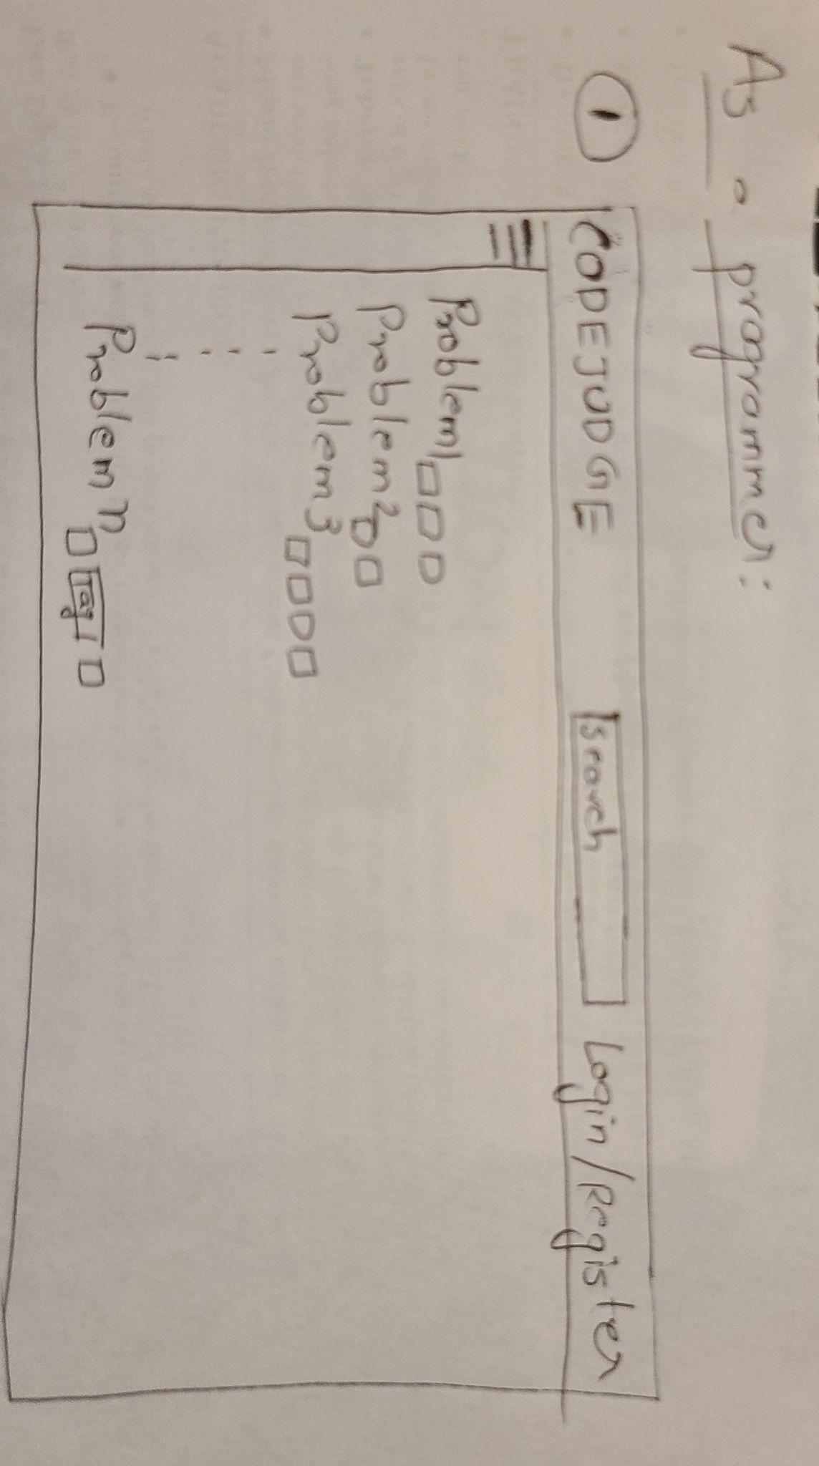

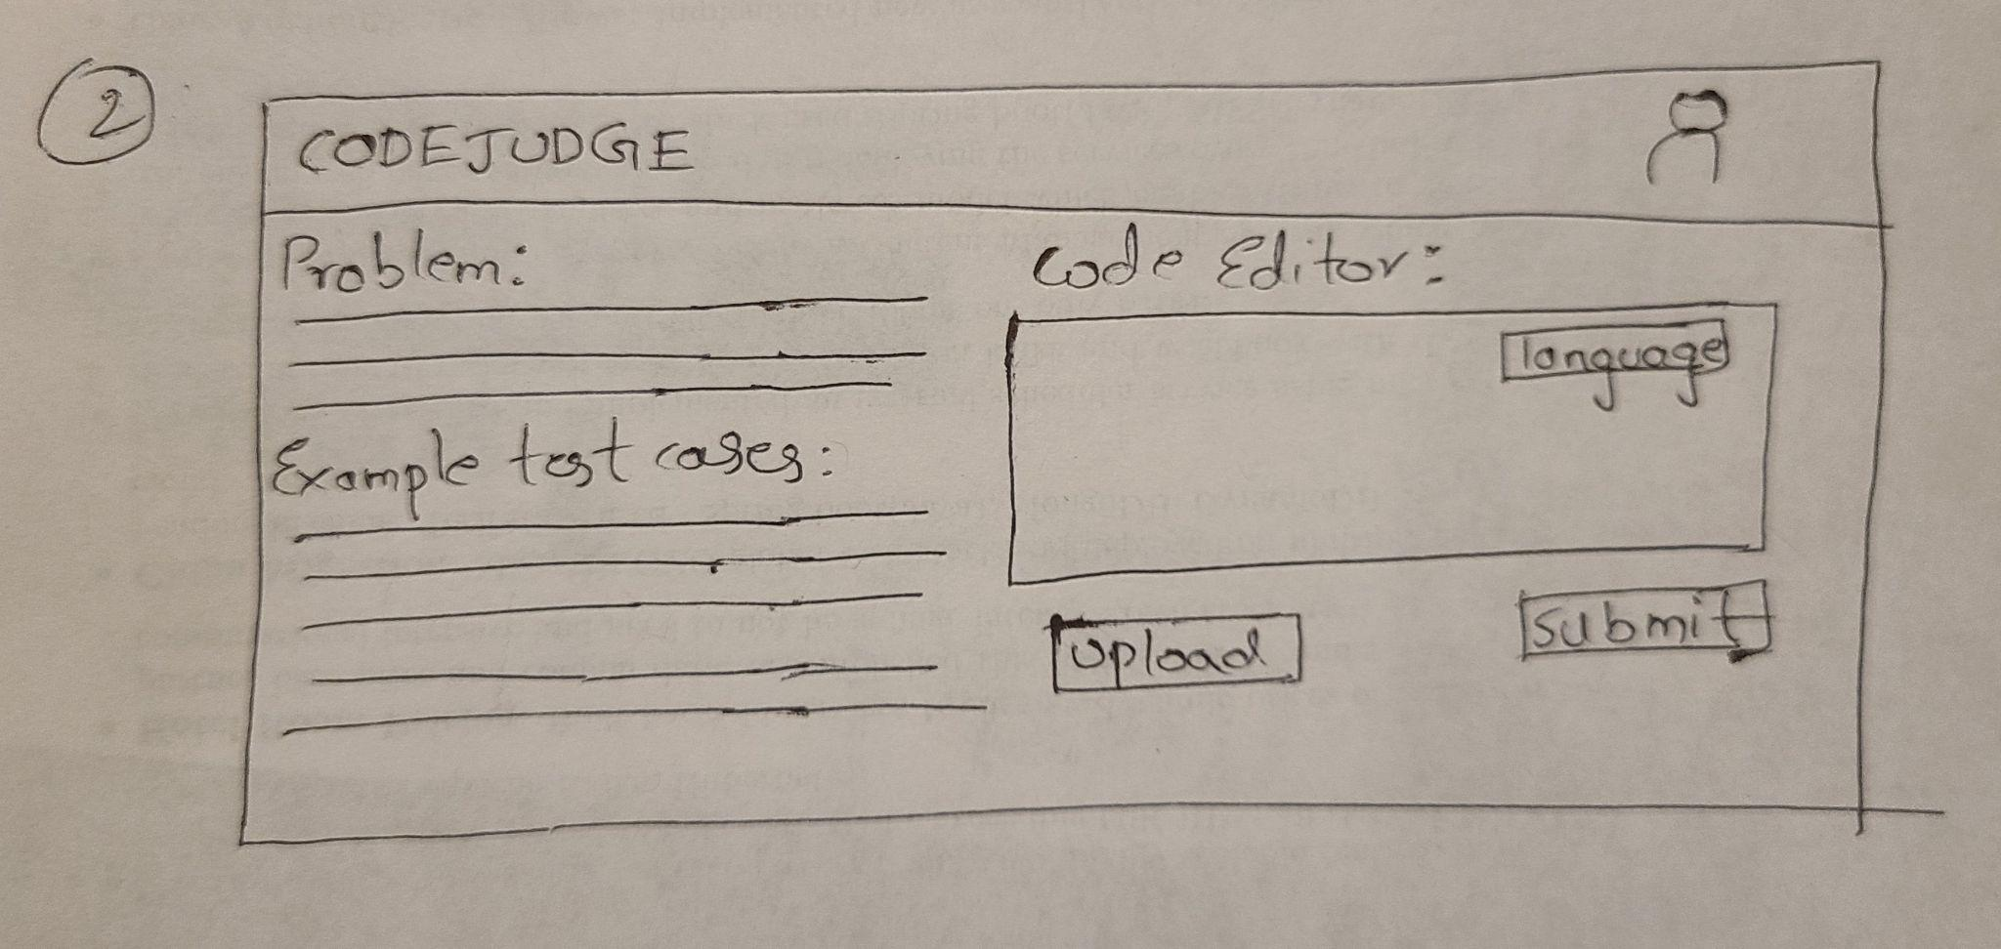

* **Instructor**

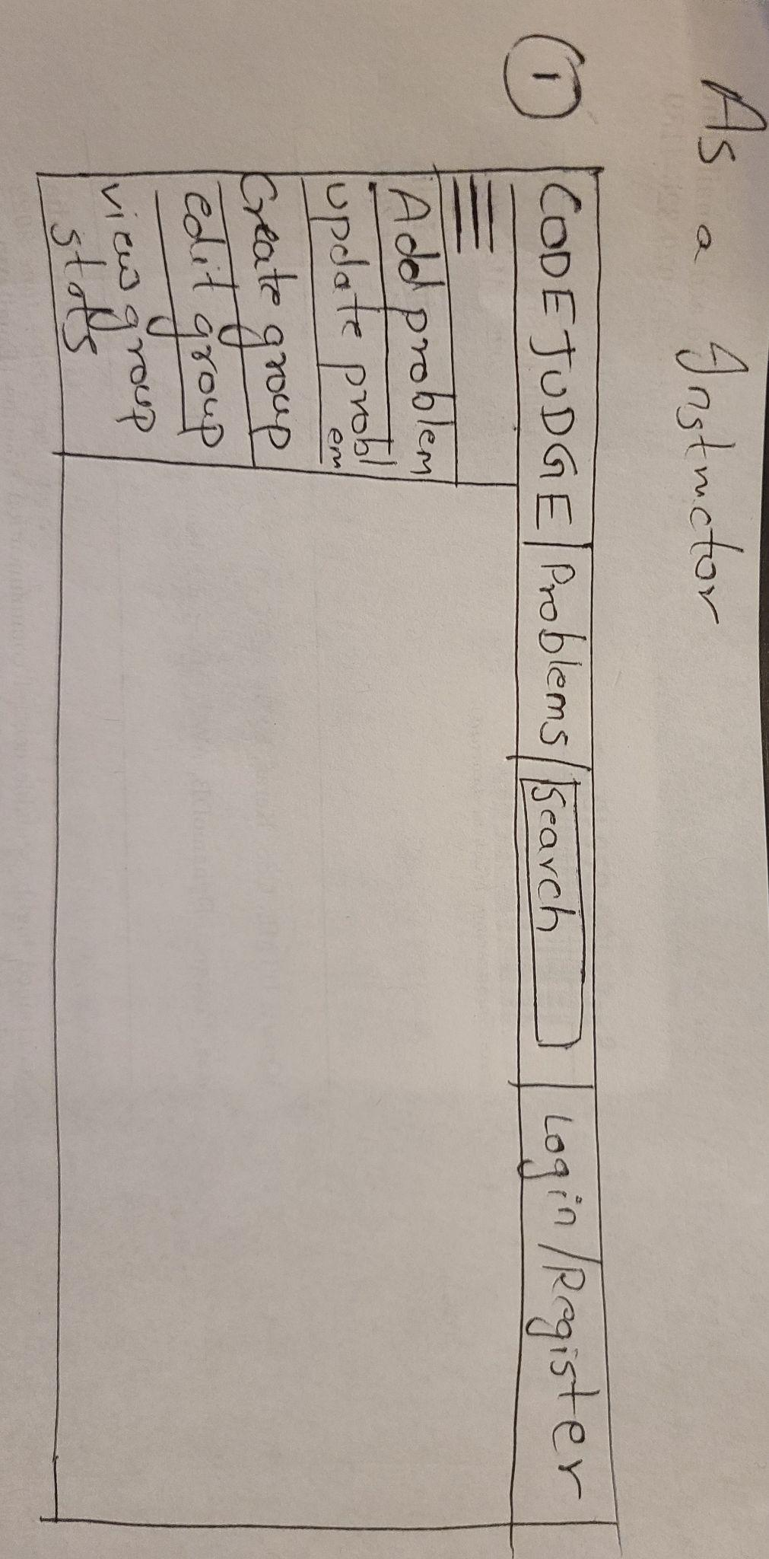

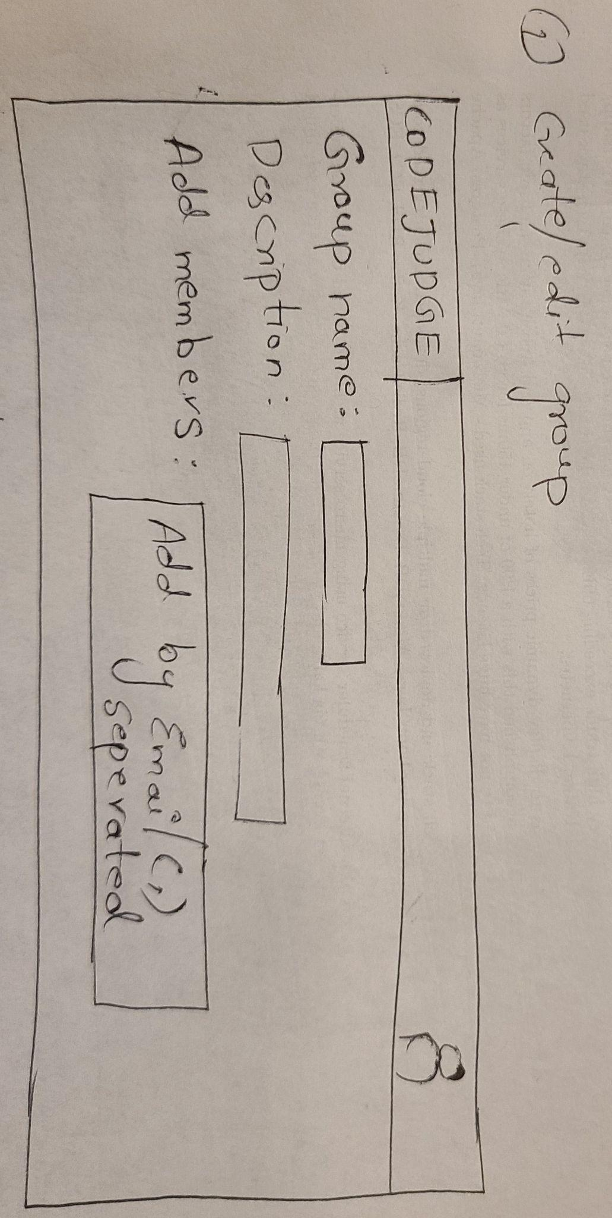

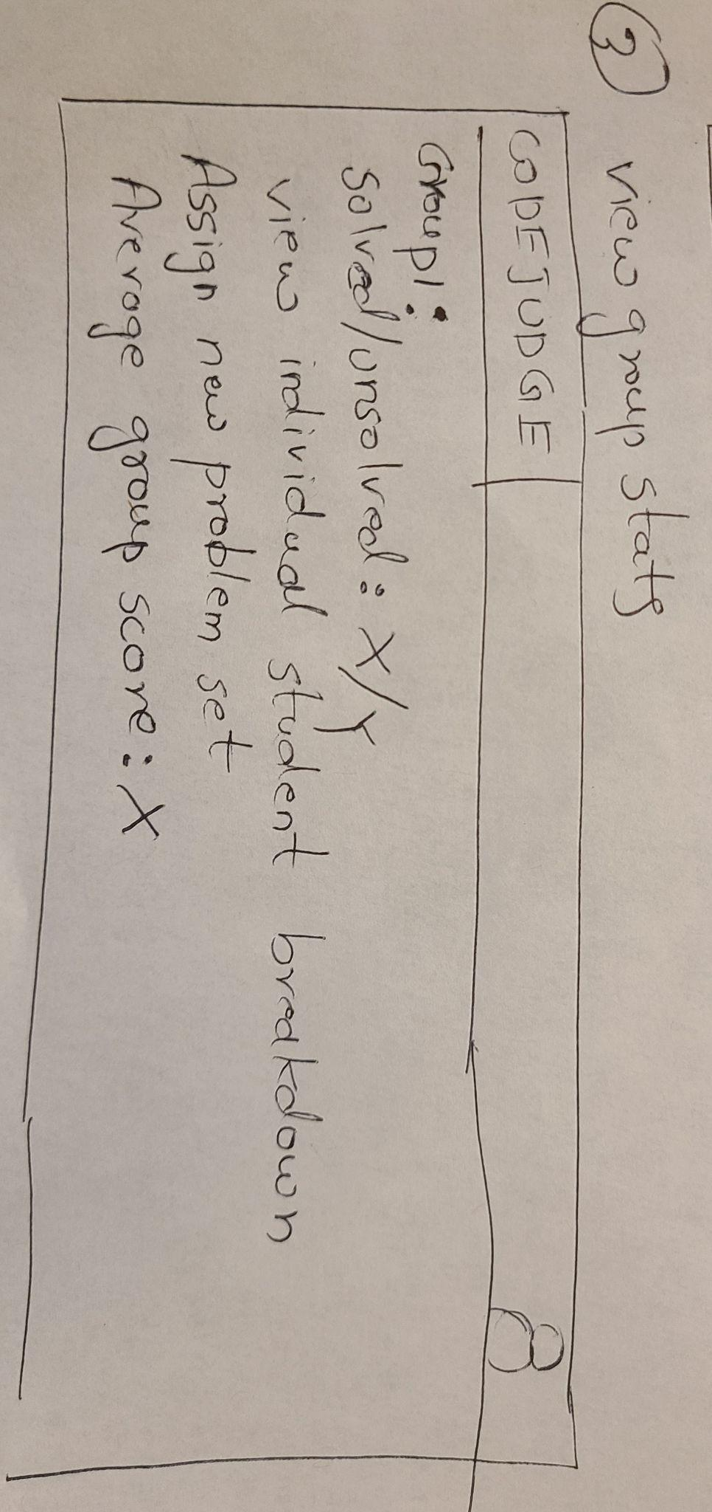

* **Admin:**

